**Mokelumne River Fish Hatchery and Artificial Spawning**

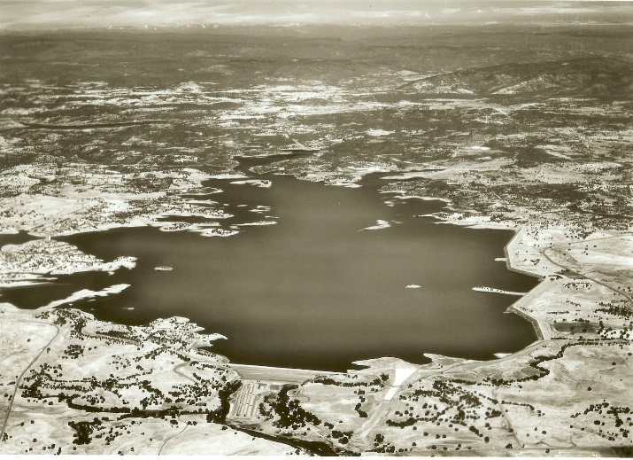**Mokelumne River Fish Hatchery**

In 1964, East Bay Municipal Utility District (East Bay MUD) built Camanche Dam to create the Camanche Reservoir. The positive result of the reservoir is that it provides flood control, a stable water supply for agriculture, and hydroelectric power, but there is a negative consequence to creating the reservoir. Chinook salmon and steelhead trout cannot pass the dam to spawn in their historical spawning grounds. East Bay MUD teamed up with the California Department of Fish and Wildlife (CDFW) to build a fish hatchery to mitigate for the loss of spawning habitat. The Hatchery was built at the same time as Camanche Dam.

Camanche Reservoir

The goals of the Mokelumne River Fish Hatchery is to raise 5.4 million Chinook salmon and 250,000 steelhead trout a year in order to mitigate for loss of habitat from the construction of Camanche Dam and to enhance commercial and recreational fishing. East Bay MUD and the Commercial Salmon Trollers Stamp fund the hatchery, and is managed and operated by CDFW.

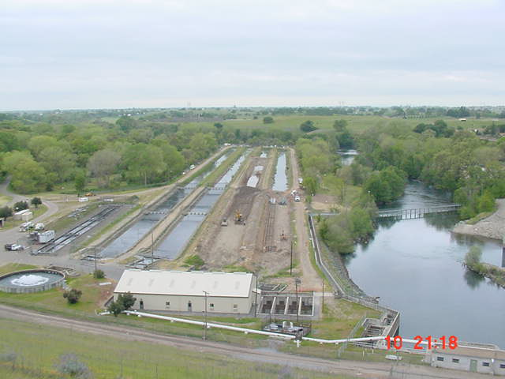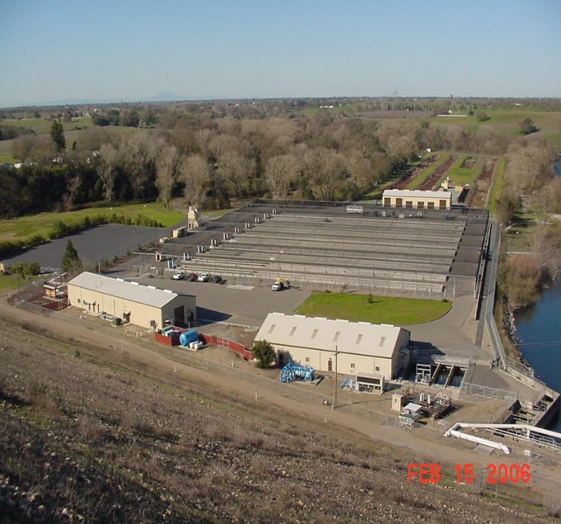

1964 Mokelumne River Fish Hatchery was built 2002 Mokelumne River Fish Hatchery was rebuilt

**Artificial Spawning**

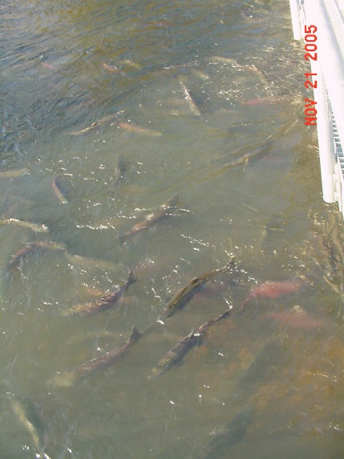

Salmon return to the river

Thousands of Chinook salmon return to the Mokelumne River between October and December with numbers of salmon peaking in mid-November, and hundreds of steelhead trout return to the Mokelumne River between November and March with numbers peaking in January. Some of these fish will spawn naturally while others will swim up to the Hatchery to be spawned artificially. The following is the step-by-step process on how both types of fish are artificially spawned.

Fish Ladder

The hatchery spawning process begins at the entrance of the fish ladder. Salmon and steelhead are attracted to moving water, so they instinctively follow the flowing water of the fish ladder up to the hatchery building. A weir, installed across the river during the salmon season and removed during the steelhead season, is used to persuade salmon to swim up the ladder since salmon prefer to spawn in large riverbeds. The weir is not needed for steelhead since they prefer to spawn in small stream and creek beds, so they instinctively travel up the ladder because the ladder mimics a small stream. Once these fish get to the top of the ladder, salmon and steelhead pass through a one-way gate, which keeps the fish from exiting the gathering tank. When there are about 200 or more fish collected in the gathering tank, the next step of the spawning process begins.

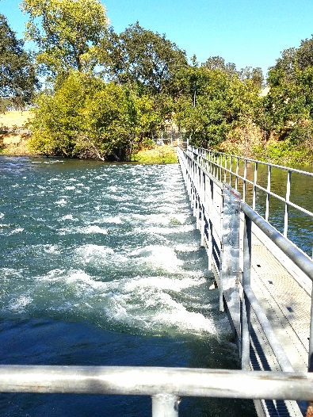

Weir

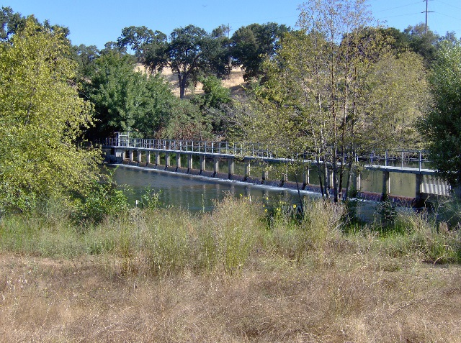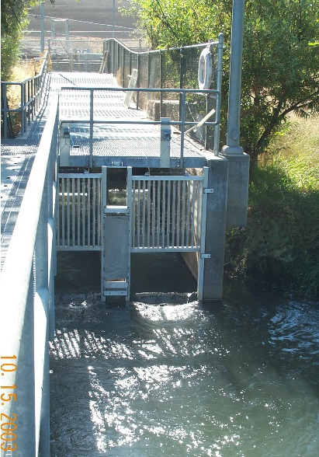

Fish Ladder Entrance

Weir

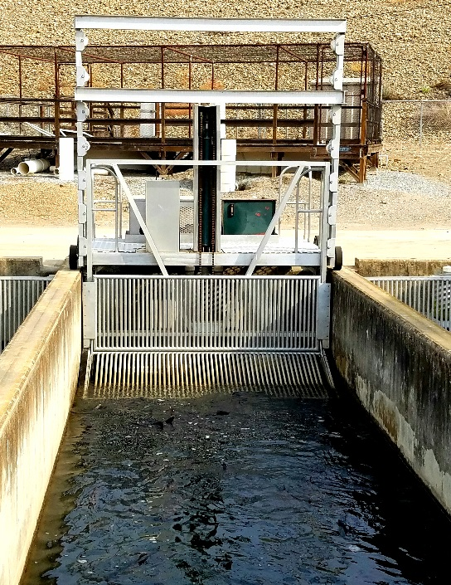Crowding the Fish

A Fish Crowder will back up to the far end of the gathering tank, lower a small weir down to the bottom of the tank, and then slowly push the fish towards the hatchery building. The fish are pushed through a hatch that opens up to a lift basket.

Electro-Anesthesia

When the fish are in the lift basket, they receive an electrical shock that anesthetizes them. This makes the fish easier to handle when being spawned. Once they have been anesthetized, they are lifted up by the lift basket to the sorting table.

Fish Crowder

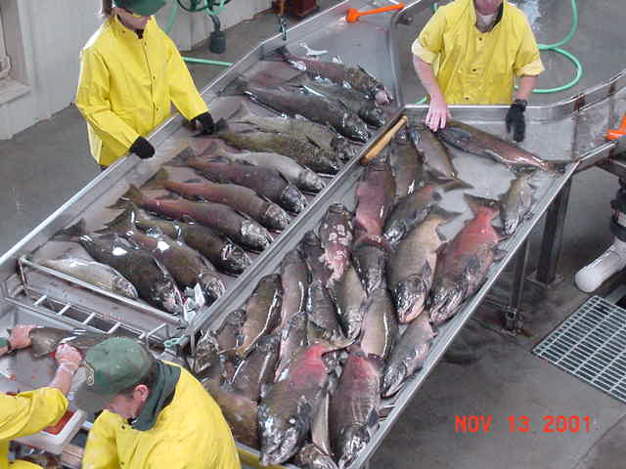

Female fish are separated from male fish.

Sorting Fish

When sorting fish, hatchery workers separate male fish from female fish and check to see if the females are ready to spawn by pressing on their abdomens. If a female is green (not ready to spawn), her abdomen will be hard, so she will be sent down a tube leading to a holding tank where green fish are held until ready to spawn. If a female is ripe (ready to spawn), her abdomen will be soft (meaning her eggs are loose in her egg sac), so she will move on to the next step of the spawning process.

Spawning Salmon

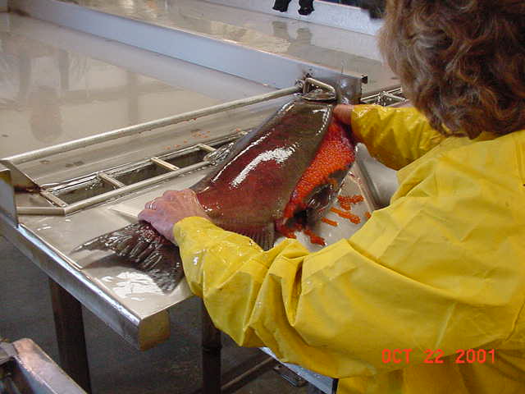

Removing eggs from female salmon

Salmon only spawn once in their lifetime then soon die afterwards. At the hatchery, the salmon are killed before being spawned to make work easier and safer for hatchery workers. Spawning starts with one hatchery worker making an incision across the female’s abdomen to collect her eggs in a spawning pan. A second hatchery worker will then squeeze a male’s abdomen to collect his milt (sperm) in the same spawning pan the eggs are in. Both the milt and eggs are mixed together, and the eggs become fertilized.

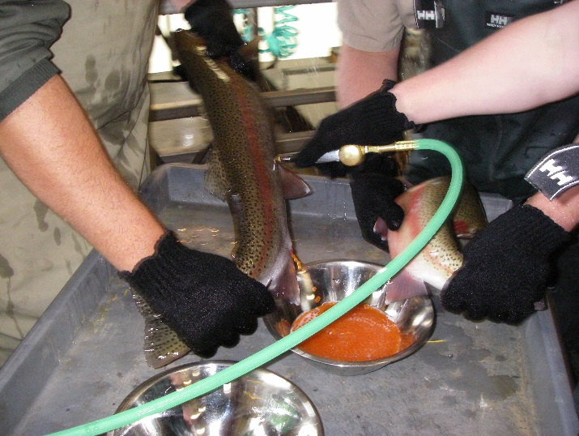

Removing eggs from female steelhead trout

Spawning Steelhead

Unlike salmon, steelhead trout do not die after they spawn. In fact, they have the capability of spawning 2-3 times in their lifetime, therefore, steelhead go through a different spawning process called air spawning. Air is injected into the female’s abdomen by a hypodermic needle which causes the eggs to be forced out through the female’s vent into a spawning pan. Then the male’s milt is collected, by squeezing the male’s abdomen, in the same spawning pan filled with eggs. Once they are spawned, steelhead are sent down a tube releasing them back to the river.

Hatching Jars

After the fertilized eggs absorb water and harden, they are placed in a hatching jar, which can hold about 76,000 eggs. The hatching jar acts like a redd where 54º F water from the Mokelumne River constantly flows around the eggs to provide them oxygen. It takes about 35 days for salmon eggs to hatch and about 24 days for steelhead eggs to hatch. Newly hatched fish are called alevins.

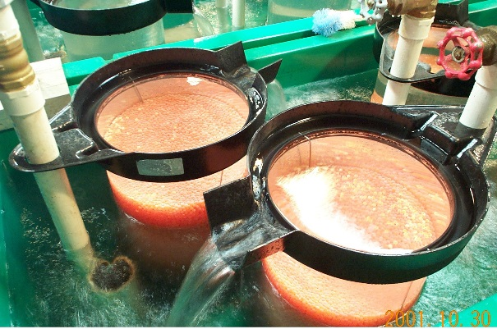

Hatching Jars

Alevin (Sac-fry)

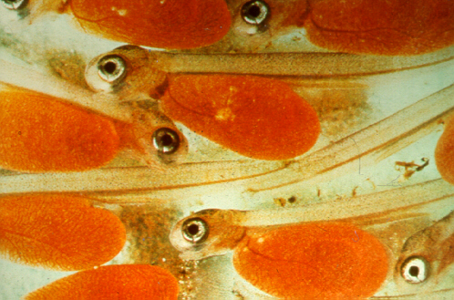

Troughs

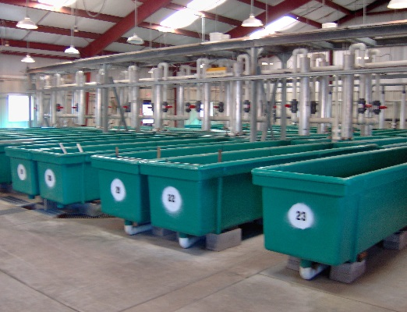

Hatchery troughs

When the eggs hatch, the fish are kept in troughs for about 12-13 weeks until they are ready to be transferred to the raceways. Salmon sac-fry take 30 days to absorb their yolks and develop into fingerlings while steelhead only take 22 days. Salmon fingerlings are fed crumb-sized pellets of food for about 4 weeks while steelhead fingerlings are fed the same food for 10 weeks before being transferred from the troughs to the raceways.

Hatchery worker hand feeding young salmon

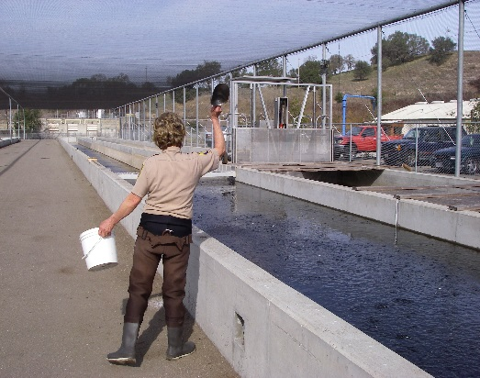

Raceways

Out in the raceways, salmon and steelhead are fed 4-8 times a day, depending on the size of the fish (the smaller the fish the more often they are fed). Salmon are kept in the raceways until they reach 4 inches in length (about 3 months) while steelhead are kept until they reach 8 inches in length (about 9 months).

Loading and Planting

Loading fish into water tank

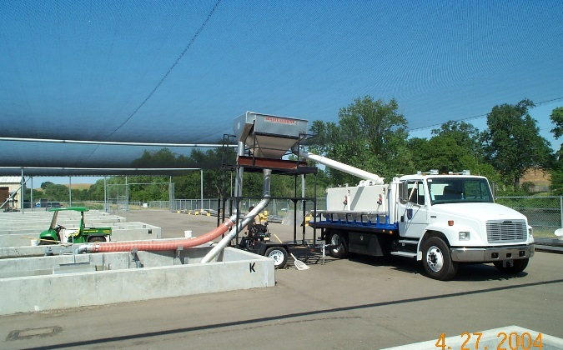

Once the fish are up to size, they are loaded into large, oxygenated, water tanks carried by large trucks and are transported to their planting spot. Salmon are planted at both the Mokelumne River and San Pablo Bay while steelhead are planted only at the Lower Mokelumne River. Once the fish are released, they will swim to the ocean to carry out their life cycle and return to the river in 2-4 years to spawn.

Mokelumne Hatchery’s Historical Time Line

**MCMP00118_0000[1]**

1848- Gold is discovered and soon after mining occurs at the Mokelumne River.

**MCPE03704_0000[1]**

1850 – California becomes an official state of the United States.

1840

1850

**MCj02306070000[1]**

1860

1861 – Copper is discovered 68 miles upstream from the mouth of the Mokelumne River at Penn Mine.

1870 – California passes an act “to provide for the restoration and preservation of fish in the waters of the state”. First state owned hatchery built in Berkeley, CA.

1870

1880

1890

1900

1919 – Penn Mine Closes.

1910

1920

1930

1937 – Penn Mine reopens and is operated intermittently between 1937 and 1956.

1943 & 1944 – The salmon run and all other aquatic life have been eliminated due to mine effluent discharge and heavy metals in the river.

1940

**MCj03291600000[1]**

1950

**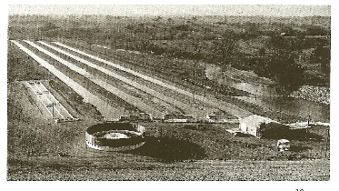**

1960

1961 – East Bay Municipal Utilities District (EBMUD) enters into agreement with California Department of Fish and Game (CDFG) to mitigate for the loss of habitat caused by Camanche Dam by building a hatchery capable of handling 15,000,000 salmon eggs and capable of rearing 100,000 yearling steelhead trout each year.

1964– The

construction of

Camanche Dam  **(“Splashes”, April 1964)**

and the Hatchery is complete. Mokelumne River Hatchery has the largest spawning channel in the world (costing more than one million dollars). This experimental spawning channel is meant to provide a cobble bed for salmon to spawn.

1970

1978 – The experimental spawning channel was abandoned in response to the changing management goals of CDFG. Portions of the channel were modified into gunnited rearing ponds to allow for longer rearing time of juvenile salmon.

1980

1987 - 1992 – A severe drought causes salmon numbers to decline in the Lower Mokelumne River and other Central Valley Rivers.

1990

1998 – Salmon Spawning Habitat Improvement Project is implemented by East Bay Municipal Utilities District and co-funded by Department of Fish and Game and U.S.Fish and Wildlife Service. This project consists of placing gravel in the river to provide more spawning habitat and to increase aquatic insect populations to provide food for juvenile salmon, so that the population of Fall-Run Chinook Salmon can increase.

2000 to present – The number of fall run Chinook Salmon returns are increasing.

2000

2002- Mokelumne River Fish Hatchery is remodeled. The new remodel is meant to provide more rearing space to allow for higher survival rates and promote fish health.